**Criterion 7 - Institutional Values and Best Practices (100)**

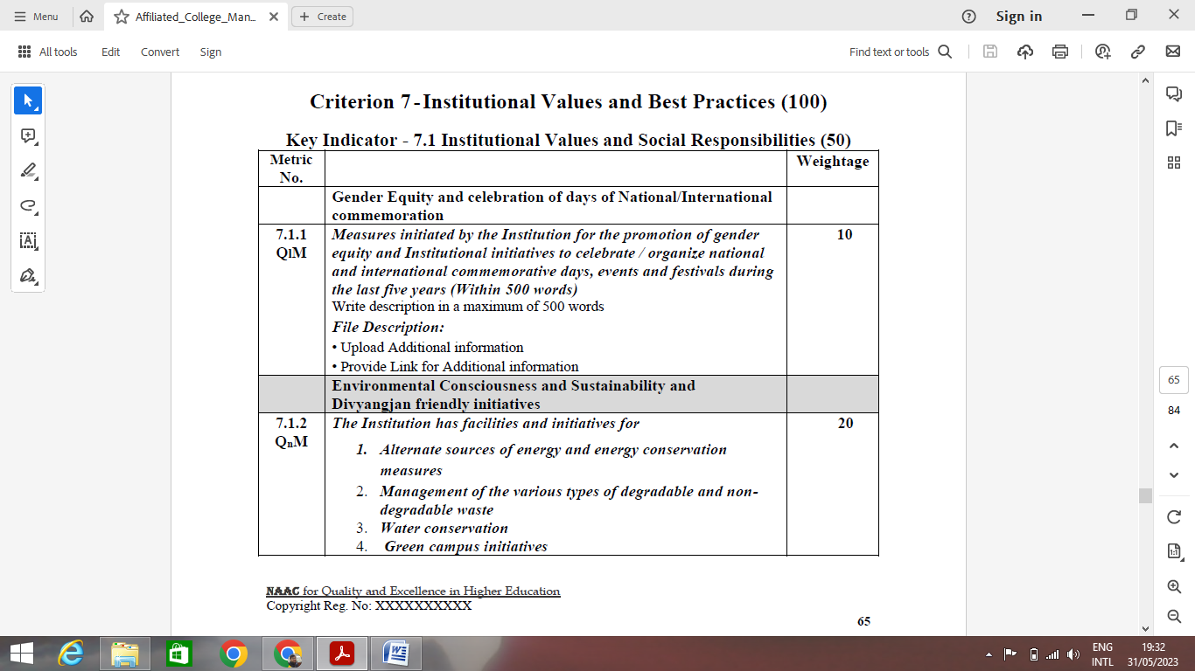

* Write 500 words
* Upload - programs organised & Photographs - (year wise)
  + Republic Day, Independence Day Photograph
  + Diwali, Ganesh Chathurti Festival Photographs
  + Holi, Ramzan, Christmas Function Photographs
  + Institution Festival Photographs (Gyanotsav)
  + Gender equity, Women's Day celebration
  + National Science Day, Environment Day celebrations
  + Program on Cyber Security for women / women education / safety of women at workplace etc.
  + Above such programs with details (circular, one page writeup, participants etc and photos

|  |  |  |  |  |
| --- | --- | --- | --- | --- |
| **Sr. No.** | **Name of the Program** | **Date** | **No. of students present** | **Attendance** |



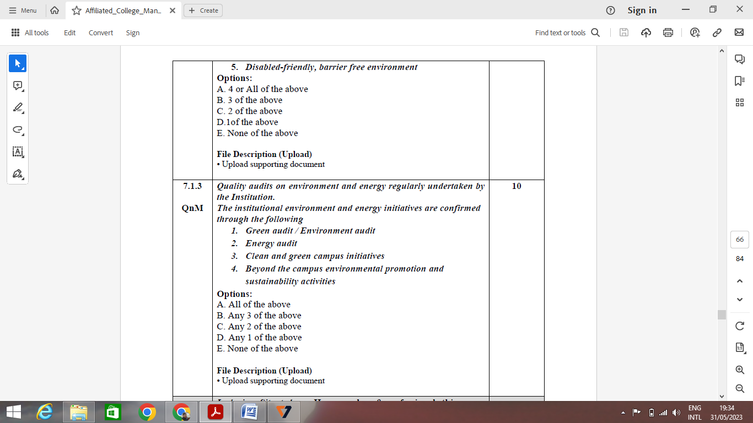

* Fill in the table as per format
* Photograph of alternate energy sources and write up
* Photograph of Ramps
* Photograph of waste management and writeup
* Photograph of RWH and writeup
* Photograph of greenery and initiatives (boards) and writeup
* Photograph of wheelchair / sign boards / wash rooms

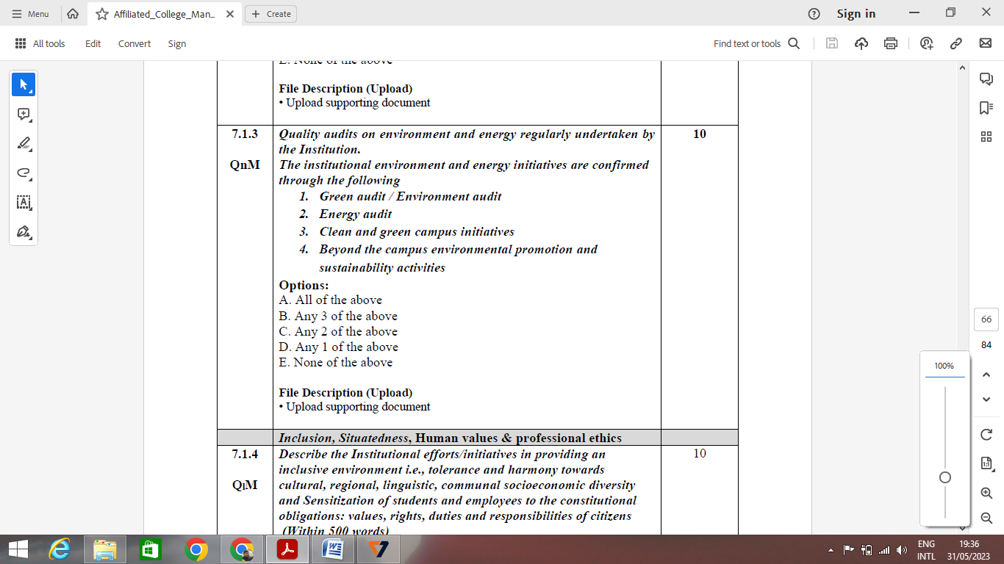

* Green audit certificate for 5 years
* Energy audit certificate for 5 years
* Clean green campus initiatives and write up
* Activities outside environment and sustainability - photos to be attached

|  |  |  |  |  |
| --- | --- | --- | --- | --- |
| S. No. | Name of the activity | Location | Date | No. of student present |

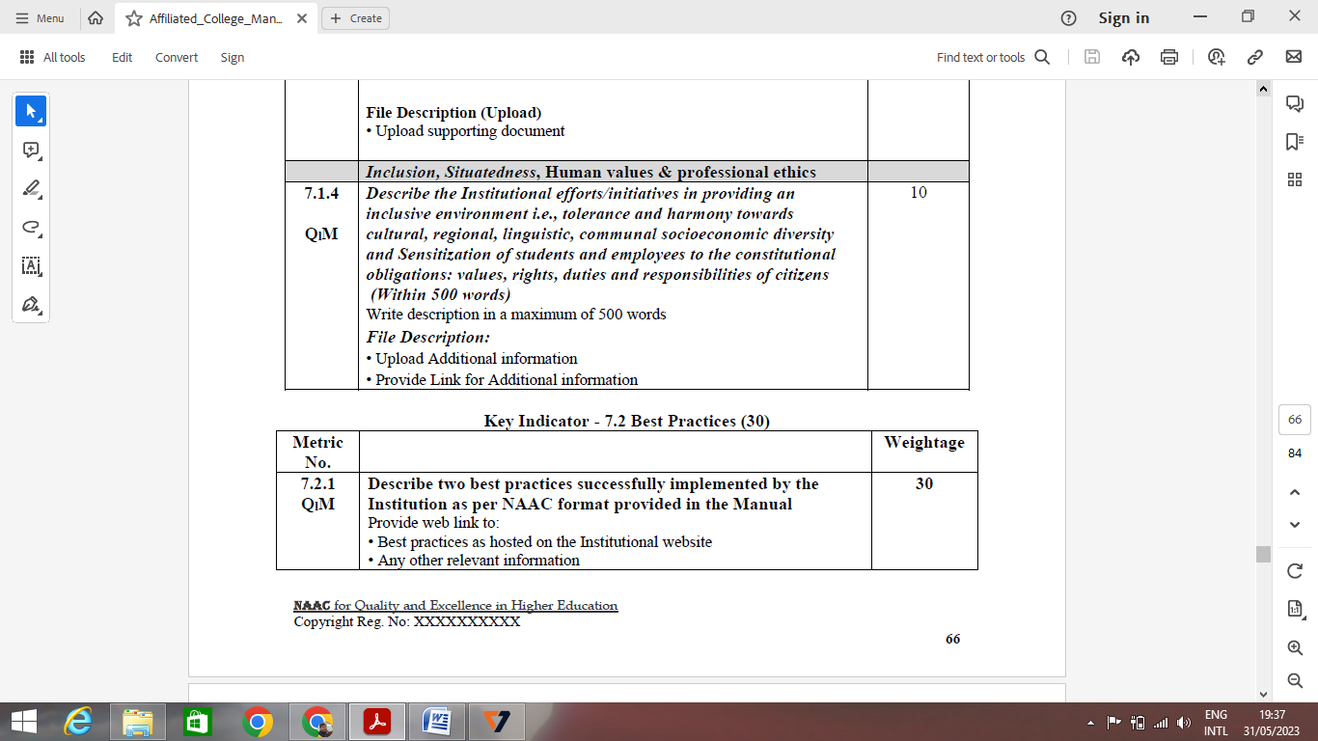

* To be written in 500 words
* Syllabus copies of Indian heritage & culture / Indian Knowledge System / Human values / environment / Indian constitution and any other courses covering above points. .

|  |  |  |  |  |  |
| --- | --- | --- | --- | --- | --- |
| **S. No.** | **Name of the Expert** | **Title of the Program** | **Date** | **No. of students** | **photographs** |

**7.2.1 Best Practices (website)**



* Two practices to be written as per the format.

Examples

1. Add on certification courses
2. Career guidance cell activities
3. Training for placement
4. Gyanotsav
5. Bridge courses
6. Faculty council

**7.3.1 Institutional Distinctiveness (1000 words)**

**To be written by including the points**

* Gold medals
* Cultural Diversity
* Faculty Performance
* Research & Development
* Teaching and Learning